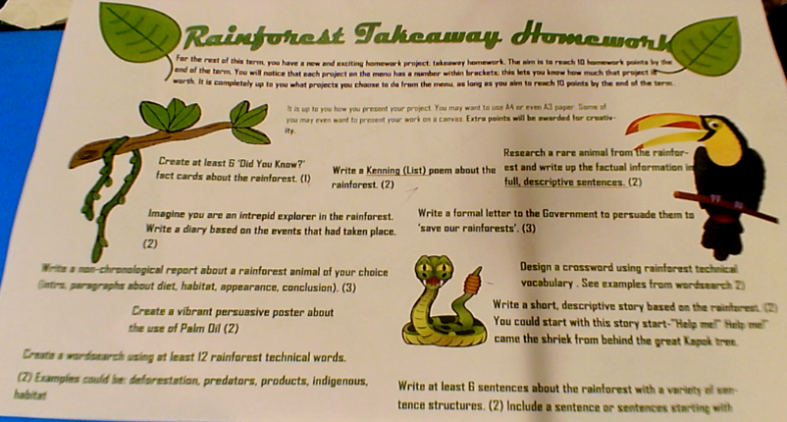

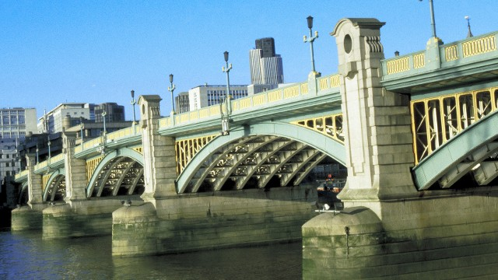
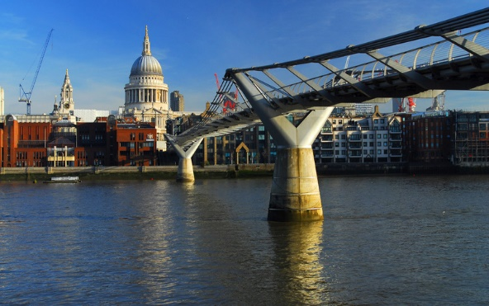

Homework for Summer Year 4

It was wonderful meeting you all yesterday and both Miss Danzey and I are very much looking forward to getting to know you all better next year. As we mentioned, we have prepared some holiday homework for you to do over the 6 week holiday. This homework, alongside daily reading practise and continuing to learn your multiplication and division facts to 12x12, will help you be prepared for year four.

In addition, we would like you to research and present something creative to celebrate your class bridge Millennium (formally Blackfriars) or Southwark bridge (formally Waterloo bridge).
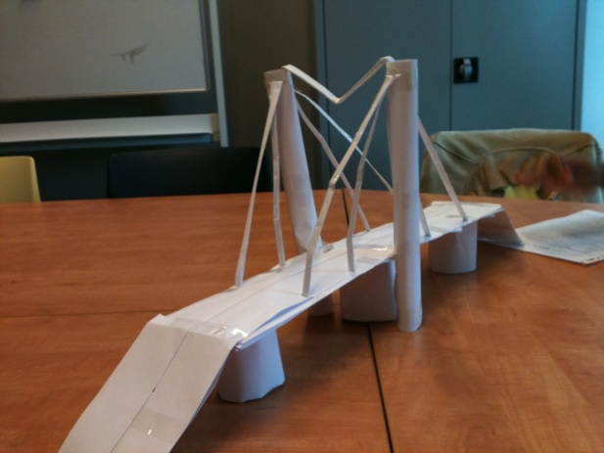

Miss Turpie Year Four Lead

