**B**

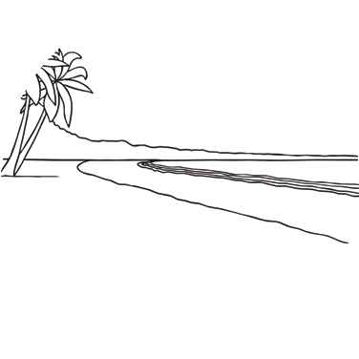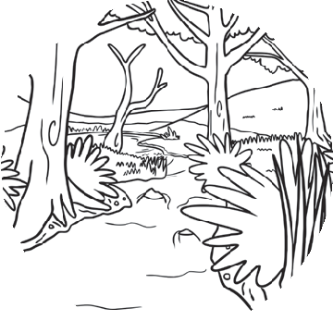

Comparing Habitats

visit twinkl.com.au

Page 1 of 4

**B**

**u**

**s**

**h**

**e**

**a**

**c**

**h**

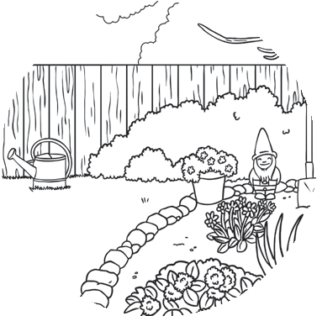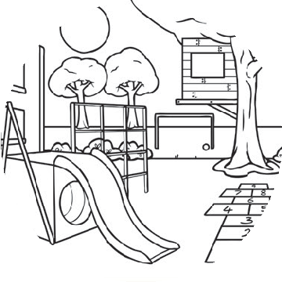

Comparing Backyard and Schoolyard Habitats

visit twinkl.com.au

Page 2 of 4

**S**

**c**

**h**

**o**

**o**

**l**

**y**

**a**

**r**

**d**

**B**

**a**

**c**

**k**

**y**

**a**

**r**

**d**

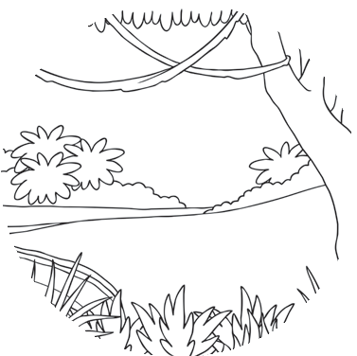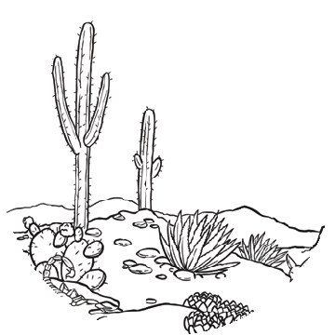

Comparing Rainforest and Desert Habitats

visit twinkl.com.au

Page 3 of 4

**D**

**e**

**s**

**e**

**r**

**t**

**R**

**a**

**i**

**n**

**f**

**o**

**r**

**e**

**s**

**t**

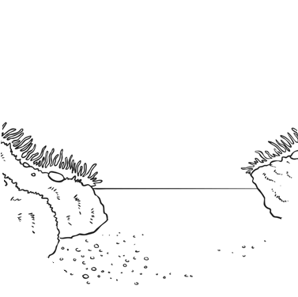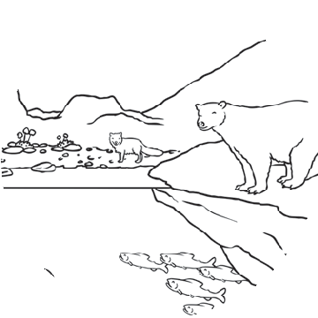

Comparing Ocean and Polar Habitats

visit twinkl.com.au

Page 4 of 4

**P**

**o**

**l**

**a**

**r**

**O**

**c**

**e**

**a**

**n**