LO: Interpret and present data using bar charts, pictograms and tables

Monkey



Tiger



Snake



Elephant



= 3 children

Can you spot the **problem** with this pictogram? **Explain** your reasoning…

Look at this **pictogram**. It shows a group of children’s favourite animal:



This bar represents how Mariam spent her **£100** birthday money…

Write down **all** the **information** you can get from this **chart**…

books

cinema

clothes

watch

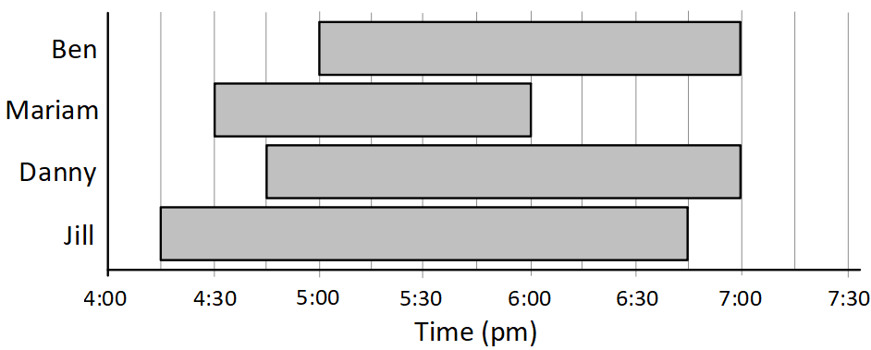

How long did **each** child spend watching TV?

This bar chart shows how when the children were watching TV one evening…

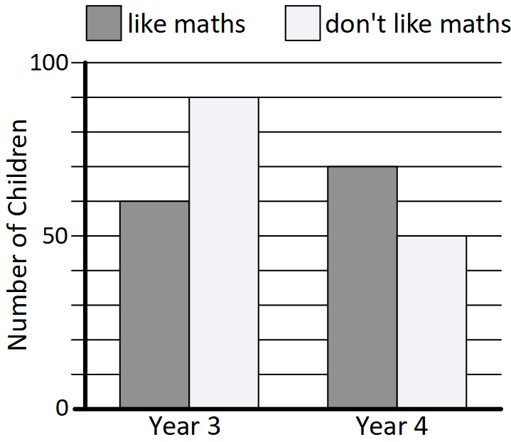

Write **questions** that could be asked about this chart…

(try to include **two-step** questions)

What does this bar chart show?

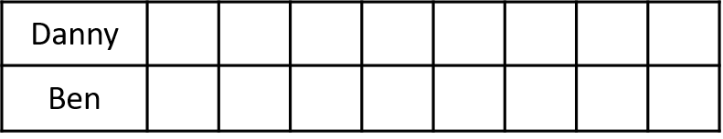

R

B

**Complete** this **table** to show what each boy could have:



blue (**B**)

red (**R**)

green (**G**)

Danny and Ben have **three** lollipops **between** them…

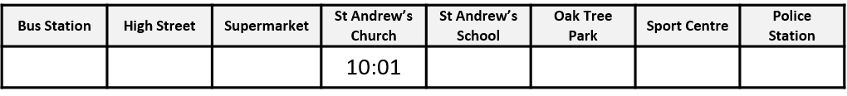

Use these **clues** to **complete** the timetable…



The supermarket is exactly **half** **way** between the **High** **Street** and the **Church**

The bus stops at the **School** at **quarter** **past** **10** and then the **Park** **3** **minutes** **later**

The **entire** bus journey takes

**58** **minutes**

The bus leaves

the **Bus** **Station**

at **9:32**

It takes the bus

**9 minutes** to get to the **High** **Street**

The bus gets to the **Sport** **Centre**

**8 minutes** *before* the **Police** **Station**

This is part of a bus timetable, but some of the information is missing:

G