Interpreting Scaled Bar Charts
Learning Objective: I can interpret scaled bar charts
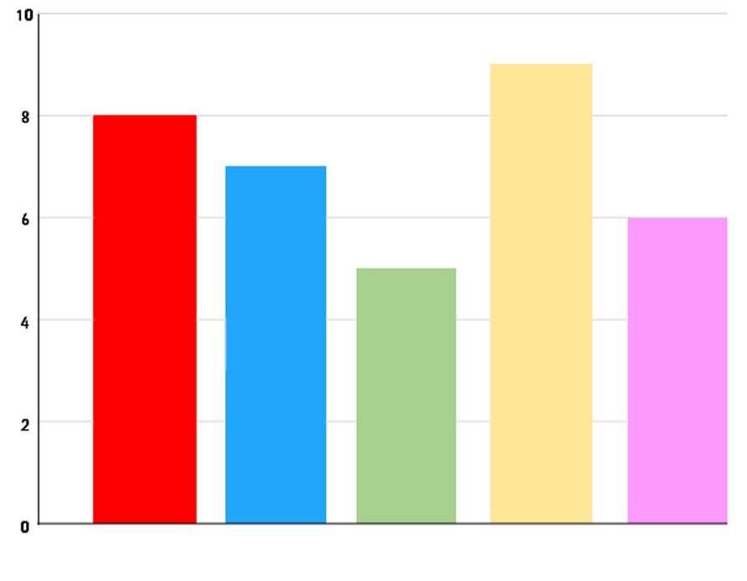
Yellow
Green
Blue
Red
Favourite Colour
Colours
Pink
Children

Blue
Green
Yellow
Pink
Red

Answer the following questions.
- What is the least favourite colour?
- How many children chose yellow as their favourite colour?
- How many fewer children chose green than blue, as their favourite colour?
- How many children chose pink and red as their favourite colour?
Write your own questions for a friend.

