Can you help Wally to find the things he has lost?

 |  |  | 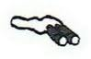 |  |  | 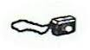
 |  |  |  |  |  |  |  |  |  |  | 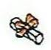
START
Directions
1. Place Wally on the start.
2. One child takes a card from the top (don’t show it to the others!) and directs the others to move Wally to the object on the card.
3. Remember to use vocabulary such as right, left, quarter turn, half turn, forwards and backwards. CHALLENGE: TRY TO AVOID THE BRICK WALLS.

