Science-Lesson 2
Recap:
The animal kingdom can be grouped into 2 groups-vertebrates and invertebrates. We have been researching the 5 groups within the vertebrate section-Mammals, Reptiles, Fish, Amphibians, Birds-Mr.Fab).
Today we will be looking at classifying animals using a sorting diagram also known as a branching diagram.
This is an example of a key (sorting diagram/branching diagram) to help classify the animals

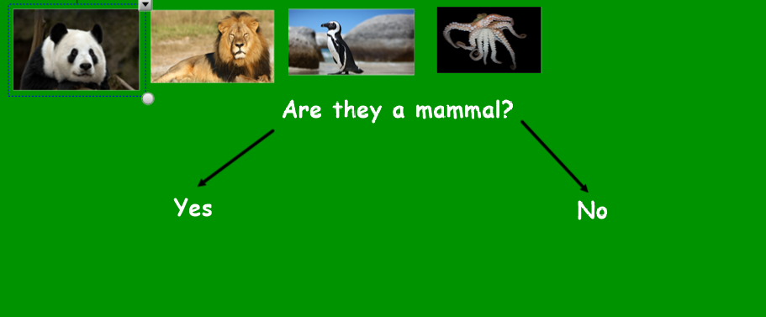
The questions require a yes/no answer. The animals that have a yes answer to the question are placed under the yes answer. The animals that have a no answer to the question are placed under the no answer.
Have a look below:
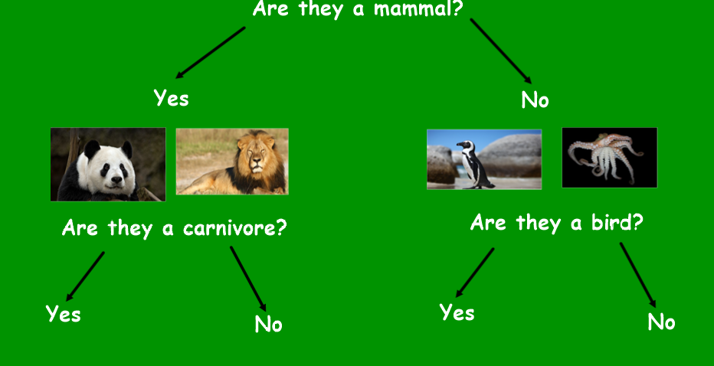
There is then a second question (yes/no answer only). Again, the animals that answer yes to the question, can then be moved to that answer. The animals that answer no are moved down to that answer.
Have a look below:
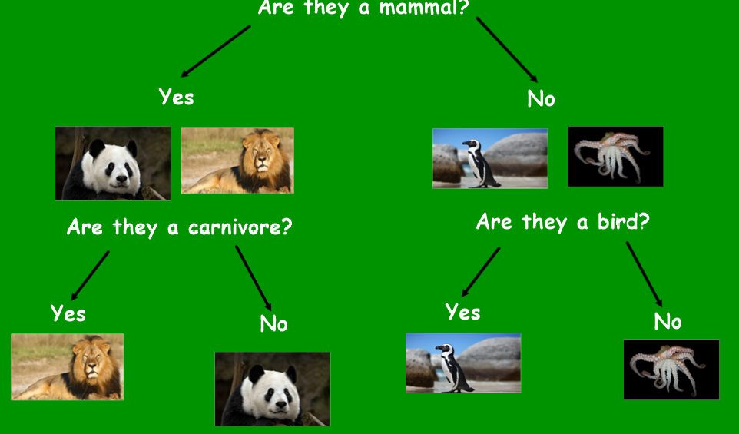
These 4 animals have then been classified into different categories. There is only one animal under each answer which means I do not have to sort them any further. I do not need to create any more questions.
In some sorting diagrams/branching diagrams, you may have to have more questions.
Tips:
The questions that you ask have to be carefully thought out to try and sort the animals
Questions need to answer yes/no only
Continue to write questions until each animal has been sorted (1 under each answer).

Below is an example of a classification key for more than 4 animals-have a look at the questions that have been asked. Notice that the questions all require a yes/no answer.
The animals that needed sorting were…..
lion, bear, giraffe, rabbit, penguin, owl, octopus, shark
- Start at the top of the diagram
- Put all the animals at the top
- Answer each question and move the animals through the diagram
- Check that the animals end up in the correct places that are already on the diagram
- Did it work?
- Could you follow each animal through the diagram?

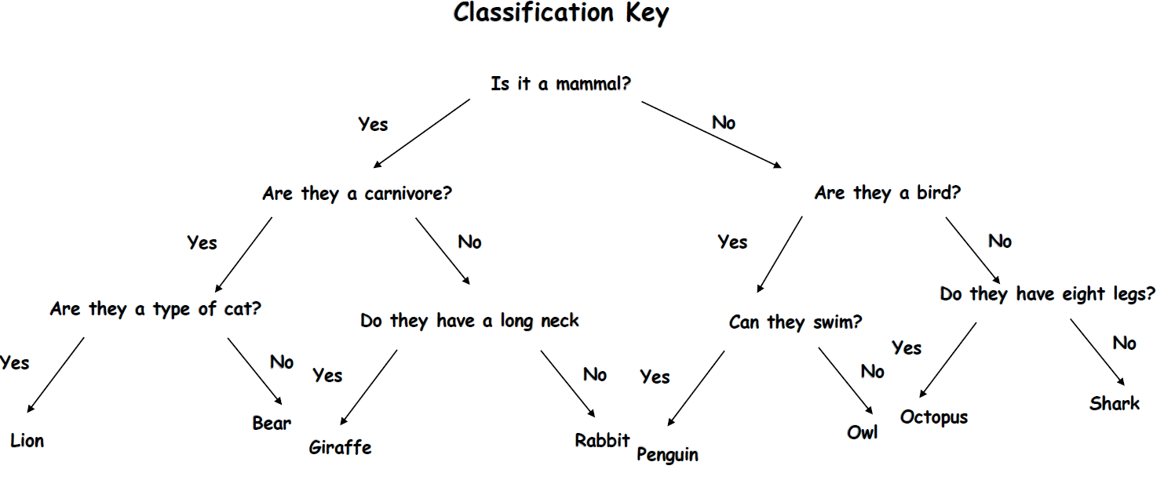

It is now your turn.
Look at the pictures of the 16 animals. See if you can create your own sorting diagram. Remember that you want to write questions that have a yes/no answer and that all animals eventually need to be on their own.
How you record it down is up to you-you can print off the animals if you can or write the names of the animals on a large piece of paper. Write your questions and sort the creatures. Take a photo of your diagram and send it to us.

