2020 National curriculum tests
Maths Paper 1 - LA

Key Stage 2

First name
Middle name(s)
Last name
Date of birth
School name

Instructions

You should work through the booklet until you are asked to stop.

Work as quickly and as carefully as you can. If you get stuck, move onto another question.

You can revisit difficult questions later. If you finish before the end, go back and check your work.

Marks

There are 5 questions and each question is worth 1 mark.

If there were 12 pupils in Year 6 and they had 2 pencils each, how many pencils would there be in total?
1

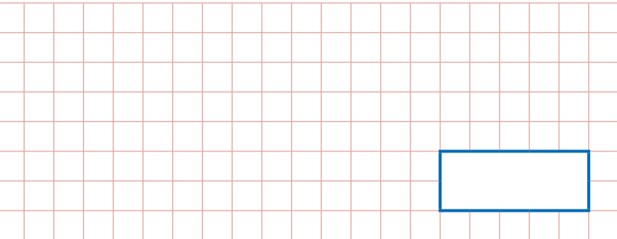

2
There are 12 pupils in Year 2 at Howard Primary School. If ¼ of them are boys, how many are boys?

Miss Blackford buys 3 large boxes of chocolate. If each box holds 10 chocolates, how many did Miss Blackford buy altogether?
3

4
Match the decimal equivalent to ½:

1.5, 0.4 , 0.2, 0.5

What is 12 + 9?
5

…………………………………………………………………………………..

