4th November 2019
POLICE INVESTIGATE MISSING BOY
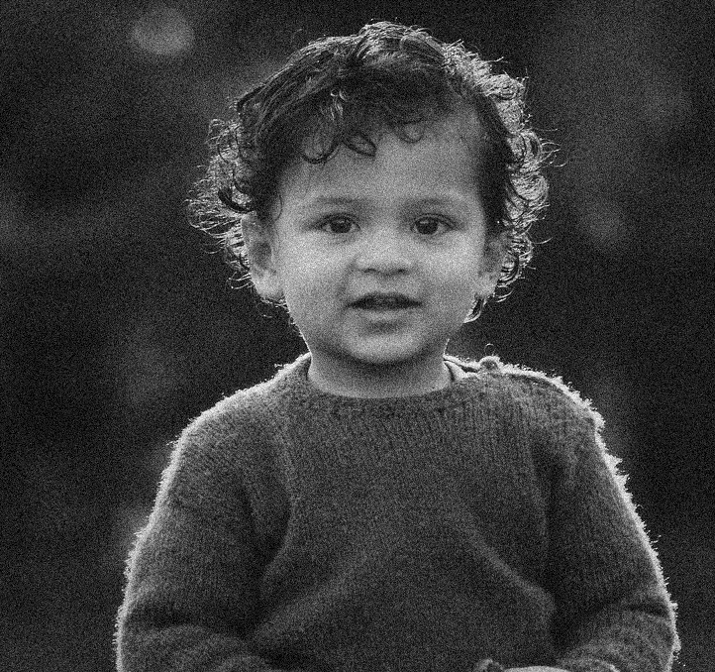
A young couple have been left devastated after their young son, Mowgli, has gone missing. The boy’s parents noticed that the child was missing when they checked on him yesterday morning at their home in Madhya Pradesh. After searching their home and surrounding area, they contacted the authorities who declared the one-year-old as a missing person.
Mowgli (the couple’s only child) was put to bed at 7pm Saturday night and nothing seemed out of the ordinary for the worried parents. They said that they checked all doors and windows were locked as usual before they went to bed too. Upon waking up, the mother went to check on Mowgli, only to find him missing. Along with members of their community, they searched for him before contacting the police department after their search was unsuccessful.
Minutes later, the local police arrived. Detective Sergeant Reddy explained, “The parents tried to find their boy but unfortunately had no luck. We have arranged our own search party, which is currently in the forests nearby, to support the effort.” He also clarified, “There are no signs of foul play and it is likely that the child has wandered off. We are treating the case as urgent considering the proximity to the tiger reserve park.”

Mowgli just before he disappeared

Police spoke to many witnesses from the area and one of those, Mr Agarwal (a neighbour) saw the boy playing the morning he disappeared. “The little boy was playing in his garden around 6am and I assumed the parents knew. I suppose the time he was playing was strange, but he went back around the rear of the house. I thought his mother had taken him in.”
Police are appealing for more information from anyone who may have seen or heard anything. They request that if you have any information that you contact them on 0125486521.

