Household resources- iron - Long time ago / Now
iron long time ago  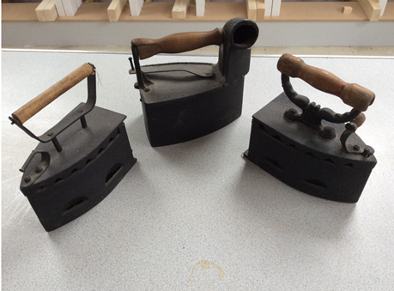 | iron – Modern (now)  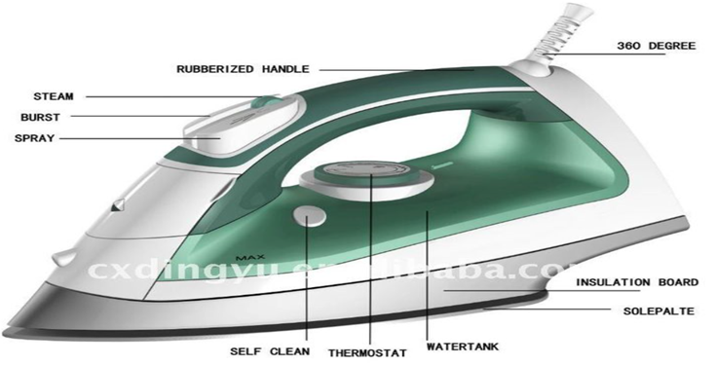
What are they made out of? | What are they made of?
Write sentences. | Write sentences.

