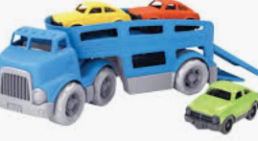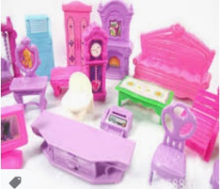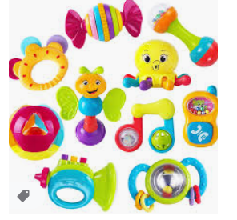**Toys**

|  |  |
| --- | --- |
| **As a baby I played with…** | **Now, I play with….** |
| Picture  **Write sentences below.** | Picture  **Write sentences below.** |
|  |  |