L.O: to subtract two 3-digit numbers

Reasoning

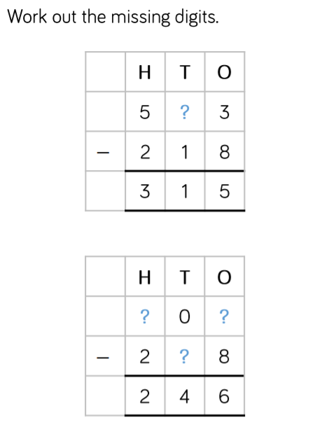

Problem solving

