- Enter ‘Language Angels’ into your internet web search engine  - You should find a Home Page that looks like the image on the right:  - Click on the green box called ‘Pupil Games Area’ (circled in red) | 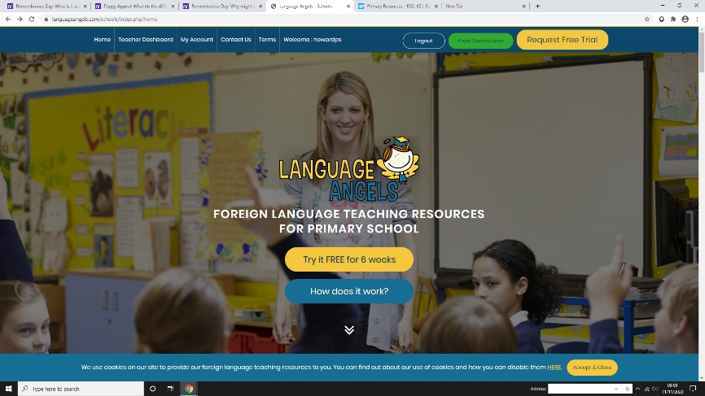
- Enter your class name as BOTH your USERNAME and PASSWORD  e.g Waterloo, QE2, Southwark etc | 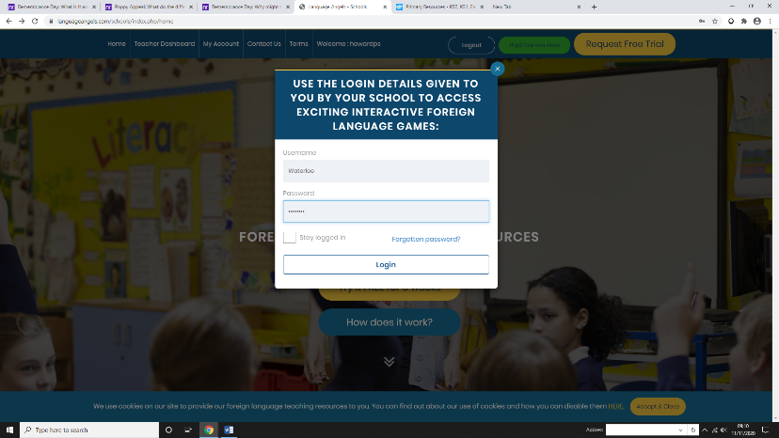
- Select whether you are playing via a desktop/computer or a tablet/mobile phone  - Select Spanish when prompted | 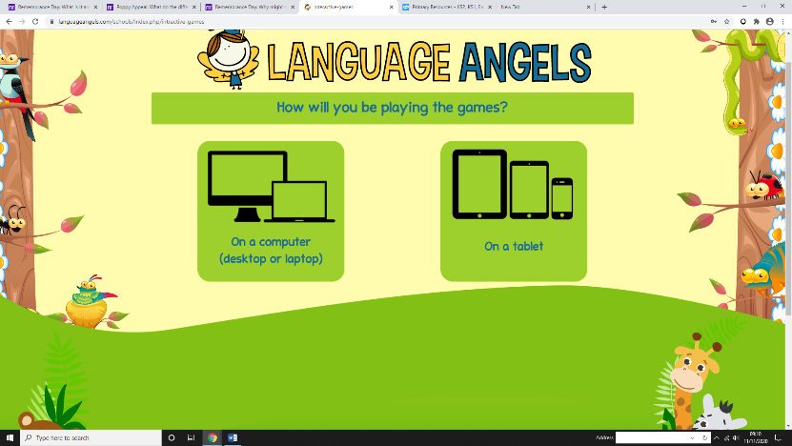
- You should see a range of topics that you can choose from  - Select the area you would like to explore | 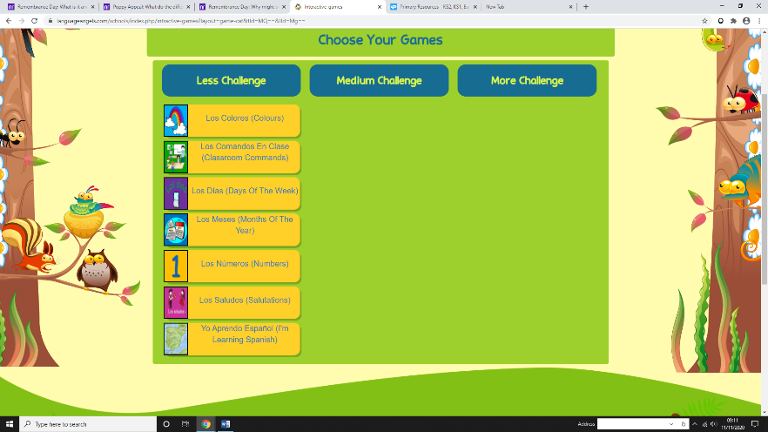
- Select the game you would like to play  - Enjoy! | 